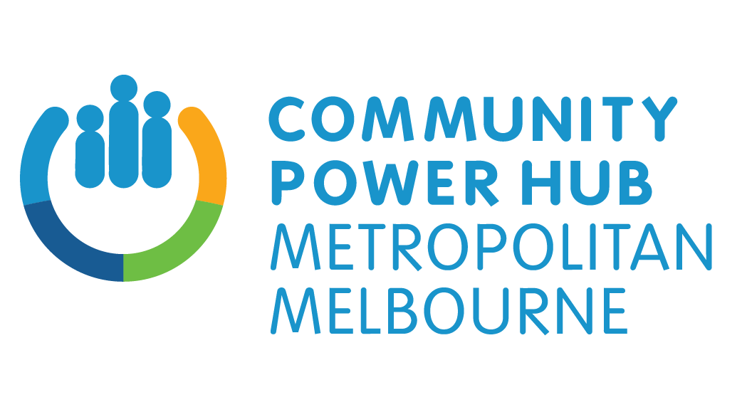

Join millions of Australians choosing solar power

Dear Householder,

Did you know that one in four Australian households now has rooftop solar power? Are you looking for powerful ways to decarbonise your home?

The Metro Community Power Hub is rolling out an all-electric solar home program in your area with up to 20% off standard retail prices for rooftop solar.

This new Hub is bringing communities together to accelerate Melbourne's transition to a zero carbon future - with a focus on local action and local projects.

Working with community climate groups, it’s led by the not-for-profit Yarra Energy Foundation, which has provided independent energy advice and services since 2010.

Whether you want solar power or to replace your gas appliances with a hot water heat pump, a heating/cooling split system or an induction cooktop - we can help.

- We connect you with our trusted and vetted suppliers.
- We’re a respected not-for-profit and will always provide independent advice.
- Our highly-experienced team can help you choose the right energy solutions.

The Metro Community Power Hub is part of the Community Power Hubs program delivered by Sustainability Victoria on behalf of the Victorian Government. You can read more at https://www.sustainability.vic.gov.au/grants-funding-and-investment/grants-and-funding/community-power-hubs.

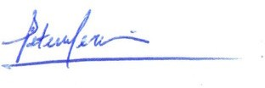
Let’s build a clean energy future - call 1800 866 634 or visit www.yef.org.au/mcph.
Sincerely,

Peter Mercouriou
Manager, Metro Community Power Hub

Learn more here:

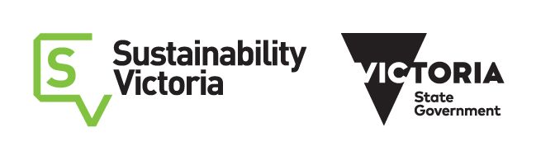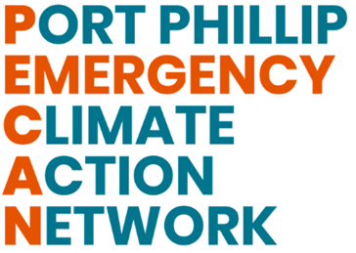

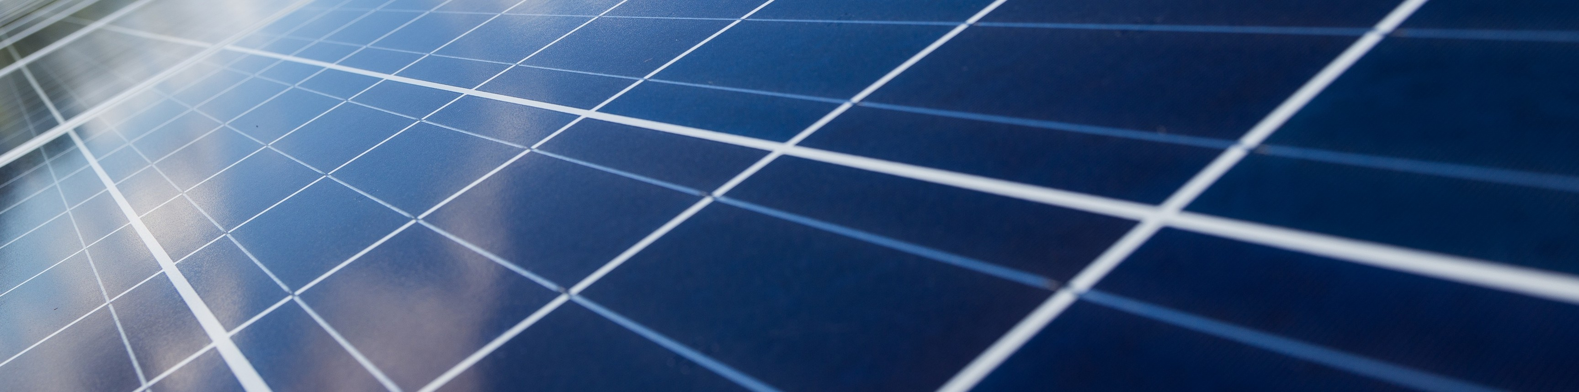
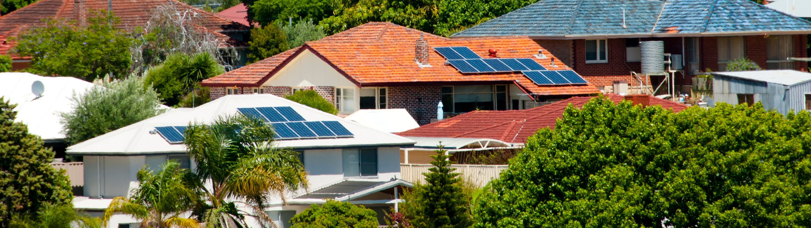

In recognition of the climate emergency we face and uniting behind the science on climate change, PECAN aims to create and sustain a strong climate action movement in Port Phillip to address the climate crisis. We’re proud to be a Roundtable Partner in the Metro Community Power Hub. You can contact us at pecan.org.au@gmail.com.
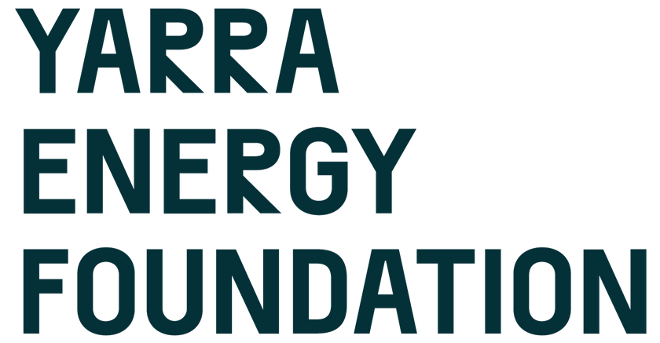

The Metro Community Power Hub is led by the Yarra Energy Foundation (YEF), a trusted and independent not-for-profit providing services and advice for homes and businesses who want better energy. Since 2010, YEF has advised more than 13,000 residents and businesses about their energy choices, and arranged the installation of more than 18,000 solar panels.

